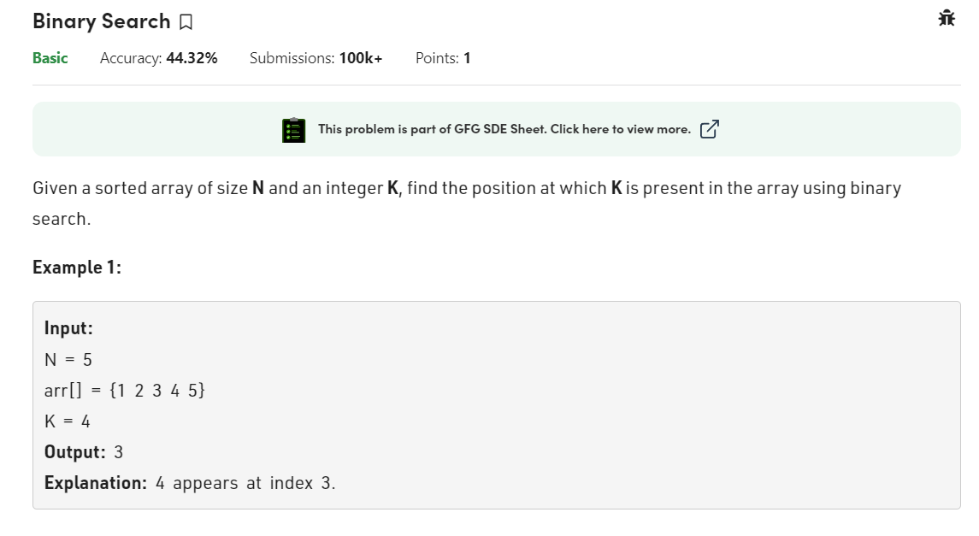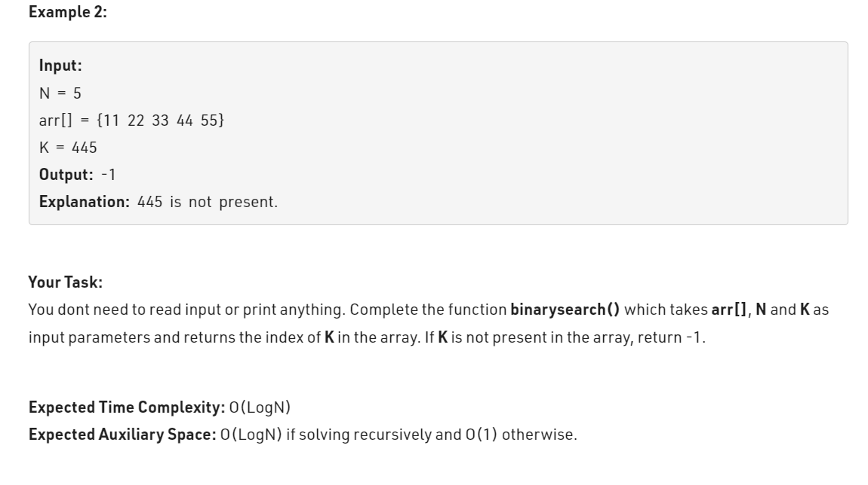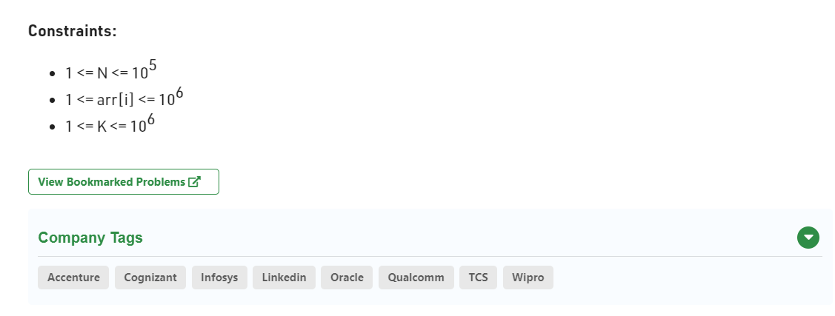

class Solution {

int binarysearch(int arr[], int n, int k) {

int start=0;

int end = n-1;

int mid = (start + end)/2;

while(start <= end){

if(arr[mid]==k){

return mid;

}

if(arr[mid]<k){

start = mid+1;

}else{

end = mid-1;

}mid = (start + end)/2;

}

return -1;

}

}

